1. 1st step

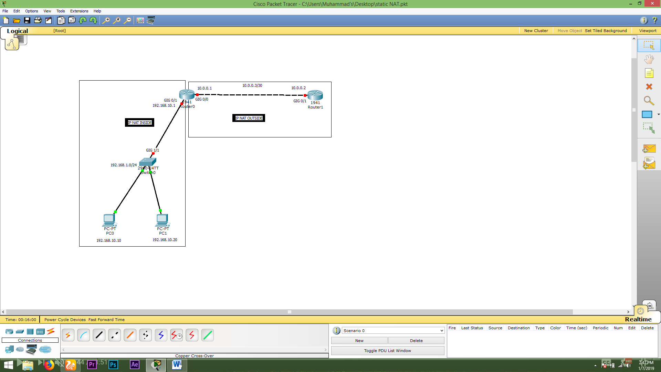

1. 2nd step

Open router Router 0 CLi Mode:

En

Config t

Interface gigabitEthernet 0/1

Ip add 192.168.10.1 255.255.255.0

No shutdown

End

1. 3rd Step

Again open router 0 Cli mode

Config t

Interface gigabitEthernet 0/0

Ip add 10.0.0.1 255.255.255.252

No shutdown

End

1. 4th Step

Then Open router 1 CLI Mode

En

Config t

Interface gigabitEthernet 0/1

Ip add 10.0.0.2 255.255.255.252

No shutdown

End

1. 5th Step

Ping pc0

Ping 192.168.10.1

Successful

Ping 10.0.0.1

Successful

Ping 192.168.10.20

Successful

Ping 10.0.0.2

Not successful

1. 6th step

Open router 0 cli mode

En

Ping 192.168.10.10

Ping 192.168.10.20

Ping 10.0.0.2

1. 7th step

Open router 0 cli mode

En

Config t

Interface gigabitEthernet 0/1

Ip nat inside

Exit

Interface gigabitEthernet 0/0

Ip nat outside

Exit

Ip nat inside source ?

Ip nat inside source static ?

Ip nat inside source static 192.168.10.10 ?

Ip nat inside source static 192.168.10.10 10.0.0.1 ?

Ip nat inside source static 192.168.10.10 10.0.0.1

1. 8th step

Open pc 0 cmd

Again ping 10.0.0.2

Successful

1. 9th step

Open router 0 cli mode

En

Show ip nat translations

Debug ip nat

->//pc0 ping 10.0.0.2 see this clearly

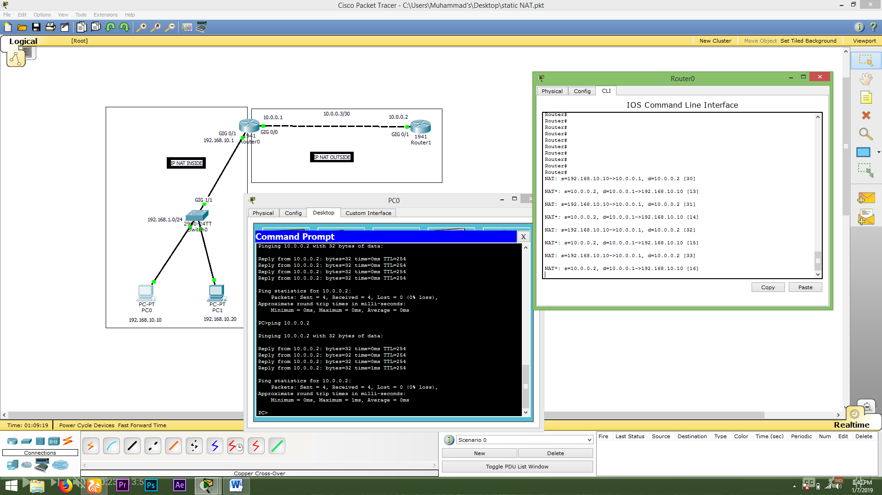Debug ip nat

1. 10th step

Open router 0 cli mode

En

Config t

Ip nat inside source static 192.168.10.20 10.0.0.100

->//if pc1 not ping to 10.0.0.2 then

No Ip nat inside source static 192.168.10.10 10.0.0.100

Ip nat inside source static 192.168.10.10 10.0.0.1

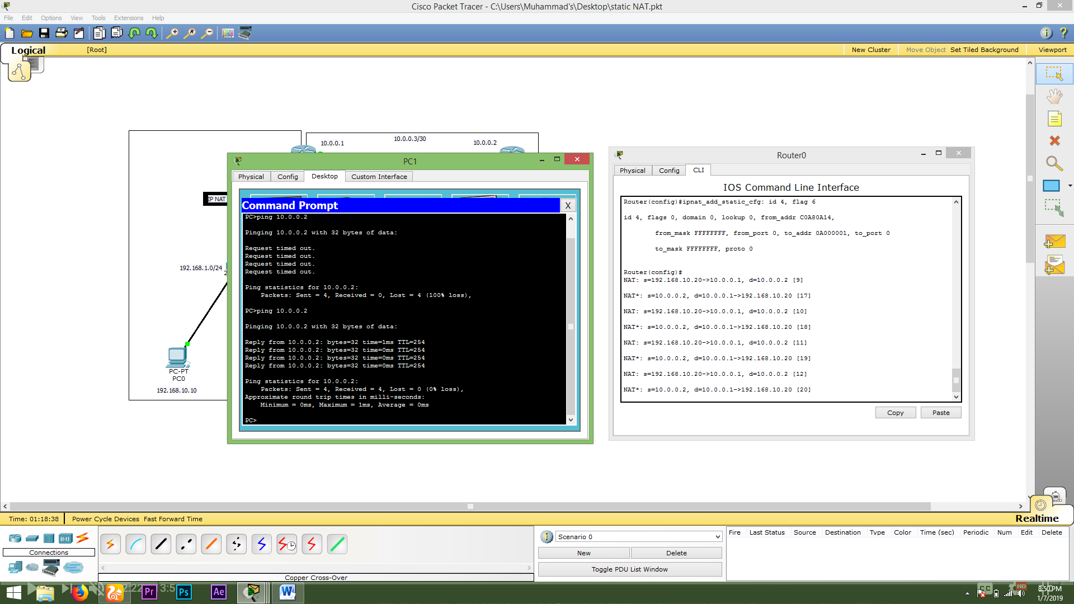

No debug ip nat

1. 11th step

Open router 0 cli mode

En

Show ip nat translations

1. 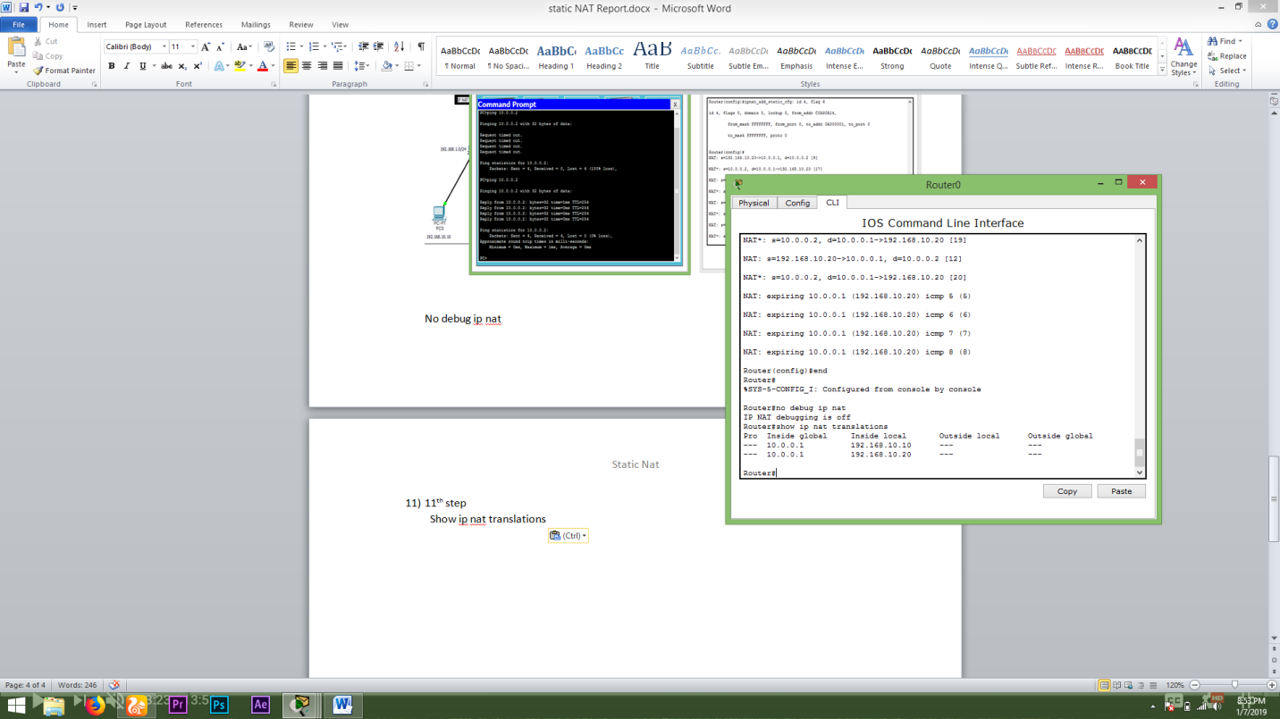12th step

Done>…..